User Manual: Doppler App

Author: Kenneth Mallabo

Last Updated: 11/04/2023

# Introduction

This document’s purpose is for the developer or use on how to use the Doppler App. It is assumed that the application has already been installed on the user’s smartphone or that the developer can run an emulator using Android Studio.

# How to use the application

## Start-up

To start the application for the user, simply tap the icon of the “project_doppler” app. If it is the developer, start the Android Studio program and then click the run button.

## Main Activity

When the application is finished loading, the user is directed to the main menu or also known as the main activity. There are two buttons, one says “What is the Doppler Effect?” and the other says “Line visualiser”. Selecting either button or the accompanying images directs the user to another activity. The view is fixed vertically.

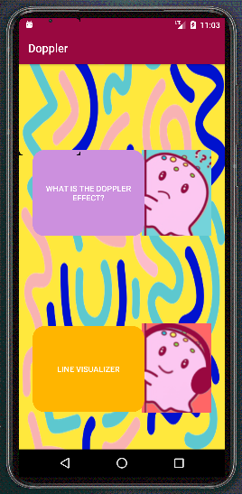

## Video activity

This activity starts automatically playing a YouTube video called “The Doppler Effect: what does motion do to waves?”. The user can pause the video, adjust the volume, enable captions, change video quality and modify playback speed. Selecting the back arrow button returns to the main activity. The view is fixed horizontally.

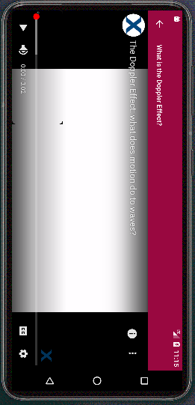

## Line Visualiser Activity

This activity allows the user to record and play the sounds in order to observe a visualisation effect to help them understand the Doppler effect. The rewind button restarts the recorded audio. Please note that this only works if an audio is currently running. The play/pause button plays the recorded audio. If an audio has not been recorded yet, then the default train audio will play instead. The mic button represents the record button and will record sound picked up by the microphone. The square button represents stop recording and will obviously stop recording audio. Selecting the back arrow button returns to the main activity. The view is fixed vertically.

